Task 1:

Output

Class

Predicted Actual

1.0 1.0

1.0 1.0

0.0 0.0

1.0 1.0

0.0 0.0

1.0 1.0

0.0 0.0

0.0 0.0

1.0 1.0

0.0 0.0

0.0 0.0

1.0 1.0

0.0 0.0

1.0 1.0

1.0 1.0

1.0 1.0

0.0 0.0

1.0 1.0

0.0 0.0

0.0 0.0

Accuracy: 100.0 %

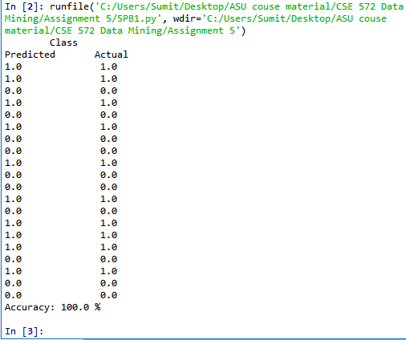

Task 2:

Output

LINEAR KERNEL FUNCTION-

Class

Predicted Actual

0.0 1.0

1.0 1.0

0.0 0.0

0.0 1.0

1.0 0.0

0.0 1.0

1.0 0.0

1.0 0.0

0.0 1.0

0.0 0.0

1.0 0.0

1.0 1.0

1.0 0.0

1.0 1.0

1.0 1.0

1.0 1.0

1.0 0.0

1.0 1.0

1.0 0.0

1.0 0.0

Accuracy: 40.0 %

POLYNOMIAL FUNCTION WITH DEGREE 5 -

Class

Predicted Actual

1.0 1.0

1.0 1.0

0.0 0.0

0.0 1.0

1.0 0.0

1.0 1.0

0.0 0.0

0.0 0.0

1.0 1.0

0.0 0.0

1.0 0.0

1.0 1.0

1.0 0.0

1.0 1.0

0.0 1.0

1.0 1.0

0.0 0.0

0.0 1.0

0.0 0.0

0.0 0.0

Accuracy: 70.0 %

RADIAL BASIS FUNCTION -

Class

Predicted Actual

1.0 1.0

1.0 1.0

0.0 0.0

1.0 1.0

0.0 0.0

1.0 1.0

0.0 0.0

0.0 0.0

1.0 1.0

0.0 0.0

0.0 0.0

1.0 1.0

0.0 0.0

1.0 1.0

1.0 1.0

1.0 1.0

0.0 0.0

1.0 1.0

0.0 0.0

0.0 0.0

Accuracy: 100.0 %

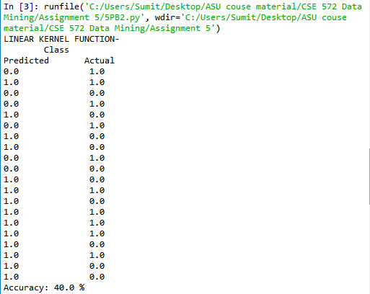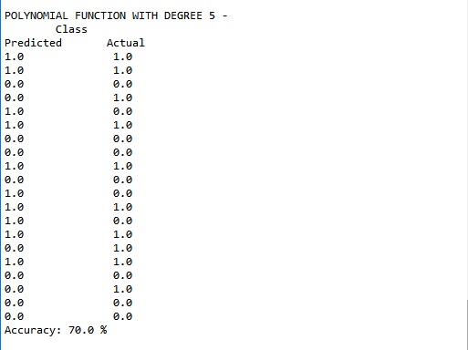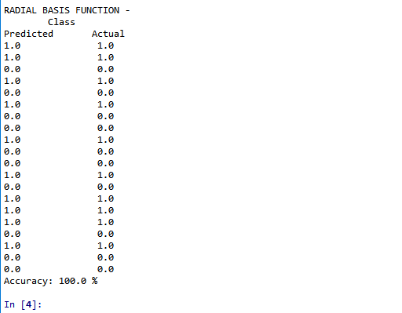

Task 3:

Output

Class

Predicted Actual

0.0 1.0

0.0 0.0

0.0 0.0

0.0 1.0

0.0 0.0

0.0 0.0

1.0 1.0

1.0 0.0

1.0 0.0

1.0 1.0

1.0 0.0

1.0 0.0

1.0 1.0

1.0 0.0

1.0 0.0

1.0 1.0

1.0 0.0

1.0 0.0

1.0 1.0

1.0 0.0

1.0 0.0

1.0 1.0

1.0 0.0

1.0 0.0

1.0 1.0

1.0 0.0

1.0 1.0

1.0 1.0

1.0 0.0

1.0 0.0

Accuracy: 43.333333333333336 %

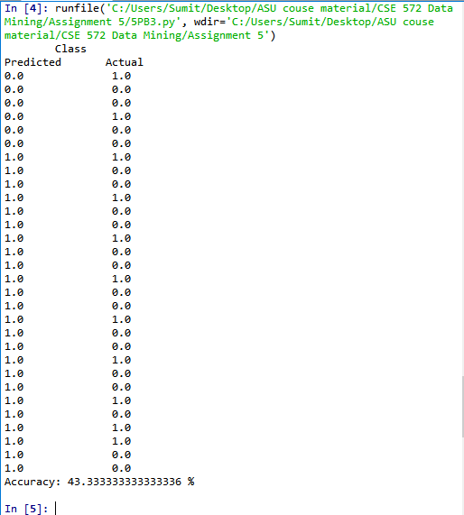

Task 4:

Output

**FYI:** For the polynomial SVM classifier of degree 7, I have used the following-

***SV2 = svm.SVC(kernel="poly", degree=7, gamma= "scale", C=0.001)***

#gamma= "scale" is used to to avoid FutureWarning Messages in scikit-learn

#C=0.001 is used as a small penalty parameter for the error gives a faster output.

LINEAR KERNEL FUNCTION-

Class

Predicted Actual

0.0 1.0

0.0 0.0

0.0 0.0

1.0 1.0

1.0 0.0

0.0 0.0

1.0 1.0

1.0 0.0

1.0 0.0

1.0 1.0

1.0 0.0

1.0 0.0

1.0 1.0

1.0 0.0

1.0 0.0

1.0 1.0

1.0 0.0

1.0 0.0

1.0 1.0

1.0 0.0

1.0 0.0

1.0 1.0

1.0 0.0

1.0 0.0

1.0 1.0

1.0 0.0

1.0 1.0

1.0 1.0

1.0 0.0

1.0 0.0

Accuracy: 43.333333333333336 %

POLYNOMIAL FUNCTION WITH DEGREE 7 -

Class

Predicted Actual

0.0 1.0

1.0 0.0

1.0 0.0

1.0 1.0

1.0 0.0

1.0 0.0

1.0 1.0

0.0 0.0

0.0 0.0

1.0 1.0

0.0 0.0

0.0 0.0

0.0 1.0

1.0 0.0

1.0 0.0

1.0 1.0

1.0 0.0

1.0 0.0

1.0 1.0

1.0 0.0

1.0 0.0

1.0 1.0

1.0 0.0

1.0 0.0

1.0 1.0

1.0 0.0

1.0 1.0

1.0 1.0

1.0 0.0

1.0 0.0

Accuracy: 43.333333333333336 %

RADIAL BASIS FUNCTION -

Class

Predicted Actual

1.0 1.0

0.0 0.0

0.0 0.0

1.0 1.0

1.0 0.0

1.0 0.0

1.0 1.0

0.0 0.0

1.0 0.0

0.0 1.0

1.0 0.0

1.0 0.0

0.0 1.0

1.0 0.0

1.0 0.0

0.0 1.0

1.0 0.0

0.0 0.0

1.0 1.0

1.0 0.0

1.0 0.0

1.0 1.0

1.0 0.0

1.0 0.0

0.0 1.0

1.0 0.0

1.0 1.0

0.0 1.0

0.0 0.0

1.0 0.0

Accuracy: 36.666666666666664 %

